Town of LaGrange Parks & Recreation

Facility Use Policies & Procedures

**Rental Reservations:** To rent any park facility for a community/business/non-profit event: For parties up to 200 people reservations need to be made online. For Parties over 200 people an online request as well as a Facility Use Application must be completed, signed, and returned to the Parks and Recreation Department along with the applicable fees and any required insurance. Reservations will not be accepted over the phone or without all paperwork and fees.

**Hours of Rentals:**

Freedom Park is open from 7:30 am – Dusk. All rentals must be cleaned up 30 minutes before the applicable closing time.

**Rental Areas:**

**Freedom Main Pavilion** Full kitchen with accessible bathroom, large commercial BBQ pit behind kitchen, approximately 22 picnic tables and comfortably holds 300+ people. You may use the grass space on the sides of the pavilion in harmony with park patrons. Up to 2 vehicles may use the access road for drop off of event supplies and no more than 2 vehicles may remain parked in BBQ pit area.

**Freedom Small Pavilion** This pavilion has no kitchen. It does have 2 large charcoal grill. Under the pavilion are approximately 10 picnic tables that will comfortably hold 80. Guests will need to walk to bathrooms. A maximum of 2 vehicles may drop off supplies at the pavilion. Those cars must be moved to the main lot after drop off. **No parking in the grass area, parking in the main lot only**.

**Cancellation and Date Change Policy: R**efunds for all programs and pavilion rentals will be processed upon request in accordance with the following policy unless stated otherwise:

* No refunds within 6 weeks of start date due to, but not limited to, inclement weather, acts of God, dismissal for behavior issues or non-usage.
* 50% refund up to 6 weeks prior to start date (first day of first session of program or event)
* All cancellation and refund requests must be in writing.

**\*Large Groups:** Any individual with a private party over 200 people, please contact the Parks and Recreation Department for further instructions to book your rental.

**Companies, Organizations, Non-Profit Groups:** Please contact the Parks and Recreation Department for further instruction to book your rental. A copy of the groups liability insurance policy listing the “Town of LaGrange 120 Stringham Road LaGrangeville NY 12540” as additionally insured must be on file 2 weeks prior to any event/usage of facilities. Each certificate of insurance should be for a minimum of $1,000,000 per occurrence and $2,000,000 aggregate for bodily injury and property damage. Higher limits may be required for special events. This is also required for any vendors coming into the park for your party (catering, entertainment, etc.)

**Alcohol:** No sales of alcoholic beverages are permitted at any Town of LaGrange facility unless a valid New York State Liquor Authority Permit is on site and posted, and permission has been granted from the Town of LaGrange. Events where alcohol is being served to guests (not for sale) are exempt from the New York State Liquor Authority permit, however, groups are still required to obtain approval from the Town of LaGrange. Private parties over 200, and all businesses/non-profits/organizations serving alcohol are required to submit insurance with their rental permit as outlined. The rental applicant shall ensure compliance with all State and Federal laws pertaining to the consumption of alcohol. Minors shall never be permitted to consume alcohol on Town premises. Open containers are only allowed in the rental applicants rented facility area. Rental applicant shall be held accountable for any act resulting from the consumption of alcohol pertaining to their event. The Town of LaGrange reserves the right to require (at the rental applicant’s expense) additional security and insurance for any function serving alcohol.

**Amusements/Entertainment:** Inflatable amusements are only allowed with group/non-profit community events with special approval by the town. **No private party rentals may bring an inflatable to the park.** Petting zoos, pony rides, animal entertainers are also not allowed at private party rentals.

**Food Trucks:** Food trucks are allowed with a health department permit from Dutchess County Dept. of Behavioral and Community Health and a Certificate of Insurance naming the Town of LaGrange as additional insured.

Propane grills are **NOT** allowed at private party rentals.

**Decorations:** No decoration or temporary fixtures may be affixed to the building or any architectural features (including picnic tables) with nails, tacks, staples, or any application that will cause irreversible damage. Use ONLY paint safe tape when hanging decorations. All decorations and tape, streamers, ribbon, etc. must be completely removed. No confetti or water balloons.

**Publicity:** Any publicly advertised event requires a permit. Conditional approval is required prior to advertising or publicizing any activity or event. The use of Town of LaGrange branding and logo(s) on any materials is strictly prohibited. Reference to the Town of LaGrange parks can only be made in reference to location of a permitted event. Event materials must contain our approved disclaimer language and be approved by the Recreation Director before distribution. No advertising should infer that the event has been produced or sponsored by the Town of LaGrange.

**Cleaning:** The facility must be cleaned and **trash must be moved to the dumpster on site at top of access road**. The facility must be vacated by the end time indicated on the Facility Permit. The rental applicant is responsible for removal of all personal articles, including leftover food, condiments and ice. All tables and garbage cans must be returned to their original location.

**Trash bags:** All garbage cans will be lined upon arrival.Rental applicants are responsible for providing additional bags as needed. Size 38” by 60”

**Cleaning & Damage Fee: $175.00 Cleaning Charge, if applicable:**

This cleaning fee must be paid within ten (10) business days after your usage if you have left the facility in unsatisfactory condition. It is the responsibility of the applicant to complete a Facility Checklist and submit to the drop box at the conclusion of the event. If the facility is not left in satisfactory condition, you will be charged time/materials to return the facility to its original condition. The drop box is located inside the small pavilion and inside the kitchen in the main pavilion.

**No future reservation will be permitted for any programs/events/reservations until the fee is paid.**

**Supervision & Law Enforcement:** Rental applicants are required to maintain control and supervision of their participants at all times. Depending on the scope of activities being conducted, a security plan may be requested. Staff are instructed to request law enforcement for immediate assistance and intervention with any individuals or organizations that do not comply with their instructions.

**Traffic Control:** Large group gatherings or non-profit/community events may be required to submit a traffic control plan.

**Noise:** Rental facilities are in a public area. Music must not be loud or offensive to the public. Music and noise must be contained within the rented space. Should the music exceed reasonable levels, the park staff will ask the designated point-of-contact to turn the music down. If more than (2) requests are made the event may be terminated.

**Smoking/Vaping:** Smoking/Vaping is not permitted in any town park or recreation area.

**Animals:** Pets are not permitted. Service dogs are exempt.

**Weather:** The LaGrange Parks and Recreation Department has the right to close the facility and cancel the rental if extreme weather or threat to public safety is imminent. You would be contacted by phone and/or email in a timely manner as the situation allows.

**Permit:** Once your reservation is approved and scheduled you will receive an email with a permit. This permit needs to be on site during your event.

**Compliance:** All groups, organizations and individuals using the parks and/or facilities will comply with all laws of the State of New York and the Town of LaGrange.

**Personal Property:** The Town of LaGrange is not responsible for any lost, stolen, or damaged personal property belonging to members of rental groups utilizing the facilities. The Town of LaGrange is not responsible for any valuables or personal property left on the premises after an event.

**Contact information:** All facility rental requests must be sent to the Parks and Recreation Department:

**By Mail/In Person:** Town of LaGrange Parks and Recreation

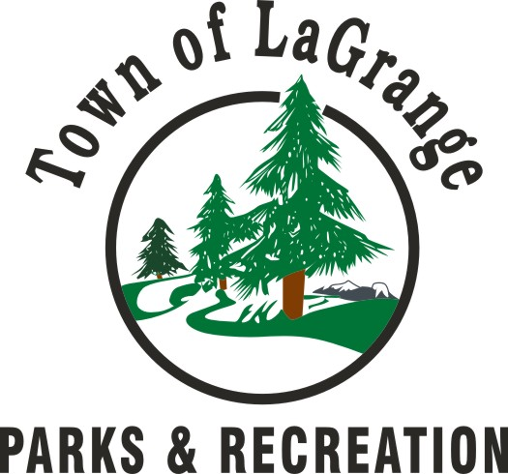

120 Stringham Road

LaGrangeville NY 12540

**Telephone:** 845-452-1972

**E-Mail:** [recreation@Lagrangeny.gov](mailto:recreation@Lagrangeny.gov)

The Town of LaGrange reserves the right to add, amend, or withdraw material contained within this document at any time; and to change or modify these guidelines at any time prior to or during an event in the interest of safety of park visitors, staff or park amenities.